Project Development Phase
Model Performance Test
Date | 28 September 2026
Team ID | 6ab221fbe880316a482c6241
Project Name | Script-Controlled ACL – Restrict Record Access Based on Field Value
Maximum Marks

Model Performance Testing:
Project team shall fill the following information in model performance testing template.
S.No. | Parameter | Values | Screenshot
1. | Model Summary | ServiceNow script-controlled Access Control List (ACL) that restricts users from viewing records unless they meet a specific condition. Only users belonging to the EEE branch can view the record; all other users are denied access. | 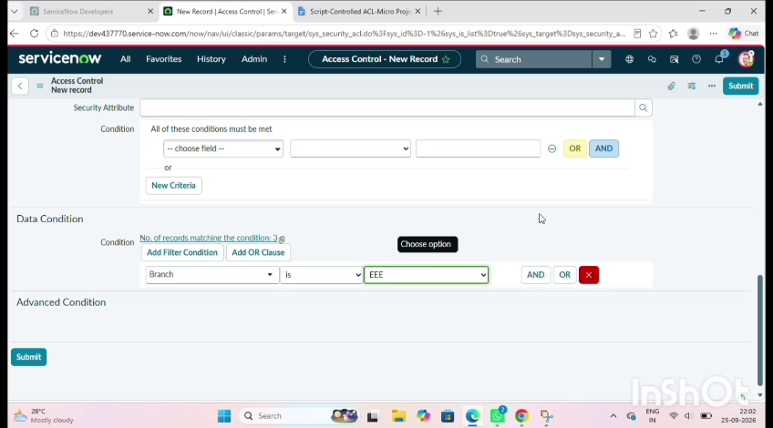
2. | Accuracy | Training Accuracy - Not applicable (no ML model used)  Validation Accuracy - Not applicable. Validated by functional testing: EEE branch user – record visible; other branch user – access denied. | 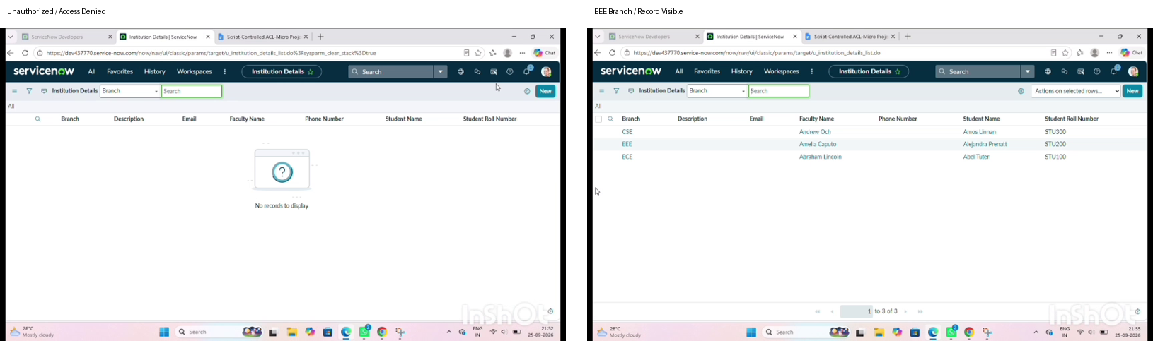
3. | Fine Tunning Result (if Done) | Validation Accuracy - Not applicable. No fine tuning done; the ACL script condition was adjusted until access worked correctly for both authorized and unauthorized users. | 